Refactoring
We should not maintain the code in a single file we maintain separate unit or modules called refactoring
As possible as much we maintain the code in separate separate components
If anything get mistkn we could replace or modify the total code
It is complex and risky to find
Maintainability is very easy with refactoring & easy to update the code

Components communication
Parent component
Child component
Multiple child components are sibling components

Parent to child
We can send the data from parent to child through props
We can send the function definition or function reference to child comp and we call in the child comp
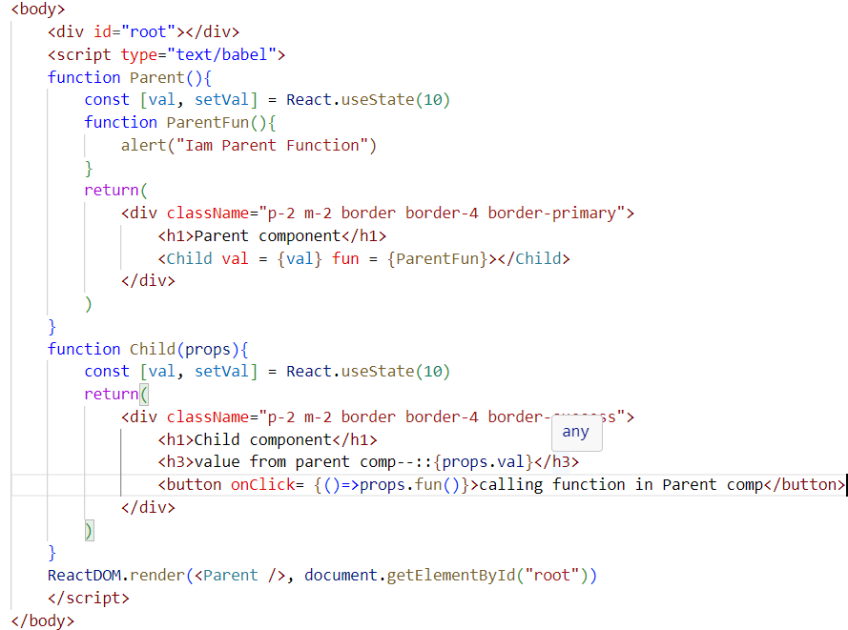

From Child to parent
We can maintain a state variable and one function to update the state variable with child value in the parent component
And pass that function to child and from child component we can call and pass the to parent through callback functionality
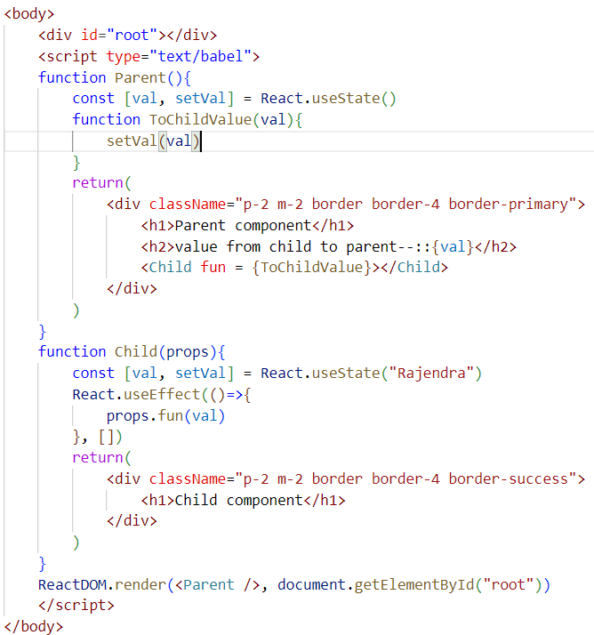

TodoList with refactoring we are maintaining the list item in child comp and data will be main component
For evry new todo item the child component will re-render to update the list item
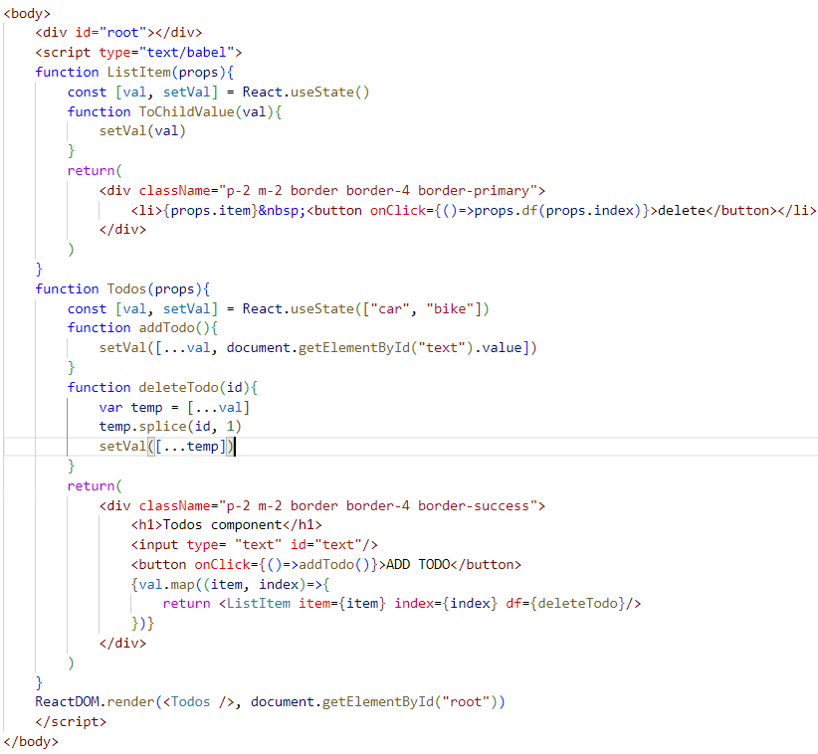

Performance Hooks

While parent component rendering the child components in the parent comp also will re-render if needed or not needed.

memo
React.memo method is used to stop the unnecessary re-rendering of components if the component does not have the props change or no need to re-render
React.memo also a HOC (higher order component)

We can define/pass our child component = list item through the memo function, so it will compare the old props and new props state then it will not re-render the same props component
Memo is protect the component to not re-render without changing the data

React.Memo checks the props equality if both are same it will stop the re-rendering

Function chary(){}
1.function definition

Var chary=function(){}
1.function expressions
2.function literals
3.assign a anonymous function to a variable

We learned refactoring/component communication
We learned reusability using props

Referential equality checking

1st case
1.we pass title to child
2.next adding the new value again, all the props send to child comp from first
3.react memo will compare the props with existing values and new values both are same it will stop the re-render

2nd case
1.we pass title and id along with a function to child
2.next adding the new value again, and all the props send to child comp from first
3.react memo will compare the props with existing values and new values both are same it will stop the re-render
4.when we are passing functions to child as props the old fun and new fun both are not same so memo will considered props are changing so it will re-render the components
Cause when the component loading all the variables & functions created/generated with a new reference value
If the same function also we are passing as props the memo considered both the functuons are not equal

If any state change in the component the component will re-render freshly except the state variables
So while re-rendering the component the old function will be erased from the code while re-rendering the component the function will be generated freshly with new reference.

useCallback

useCallback will accept the 2 parameters one is function and anethor one is dependency

useCallback is help us to stop the re-creation of function while component re-rendering time
So it will hold the old reference of that function

useMemo

useMemo and memo both are different
Memo is HOC used to functions’
useMemo is used to primitive variables
useMemo accept 2 parameters 1 is callback function and 2 is empty array dependency

